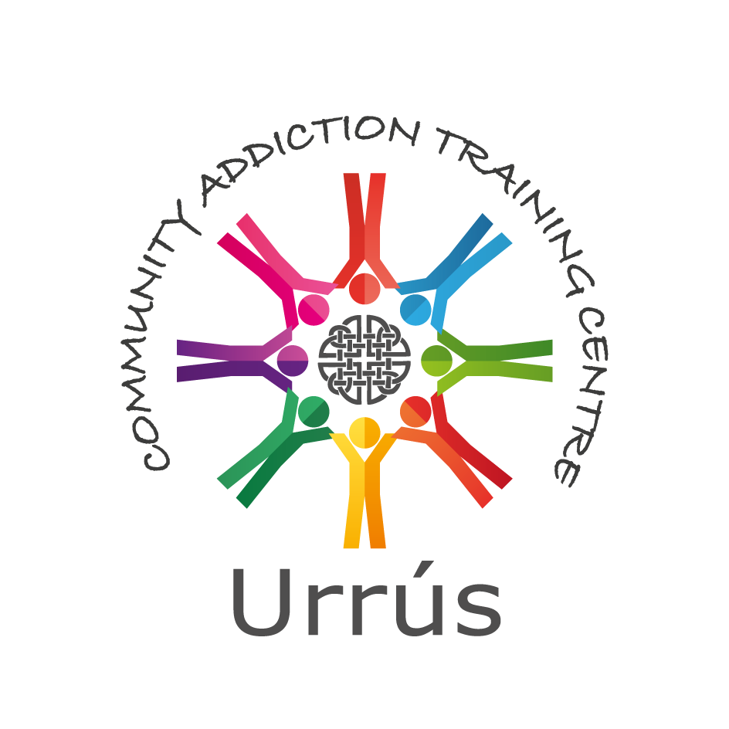

Horizons Centre, Balcurris Road, Ballymun, Dublin 11, D11 X2EP. Phone: 01 8467980 Fax: 01 8467981

Email: urrus@byap.ie Web: [www.byap.ie](http://www.byap.ie)

### Diploma in Community Drug and Alcohol Work

Urrús/ The Ballymun Youth Action Project, in partnership with University College Dublin (UCD) are offering a Diploma Course in Community Drug and Alcohol Work. Apart from responding to the need for progression routes highlighted by many people who have participated in the Community Addiction Studies Course©, we also believe it will provide a much needed source of further training to those already involved in the drugs/addiction area, whether this be in the community, voluntary or statutory sector.

This programme will be conducted over two semesters in the academic year 2022/23.  Prospective students need to be available to engage in learning and study for the full day on Tuesdays, as well as some Thursdays and Saturdays during the semester.

Both Urrús and UCD has a commitment to providing opportunities for lifelong learning and sees this avenue as an important strategy in the individual’s personal and professional development.

Who it is for?

People who wish to develop their knowledge and skills in the area of Community Drug and Alcohol Work.

What it will cover?

The modules covered during the course are: -

* Nature and Context of Addiction
* Community and Group Work Theory and Practice
* Understanding Prevention and Support in a Community Setting
* Social Policy and Drugs Policy
* Introduction to Counselling
* Reflective Practice
* Approaches to Treatment and Rehabilitation
* Motivational Interviewing
* Professional Work Practice
* Community Research Methods.

Awarding Body: -

University College Dublin, The National University of Ireland.

Diploma in Community Drug and Alcohol Work

How it is structured?

The Diploma Course will be delivered one day a week on Tuesdays (10am-5pm), plus three Thursdays (6:30pm-9:30pm) and seven Saturdays (10am-5pm) over the academic year. It is a one-year course, and runs from September to May.

Progression Routes: -

This programme offers a progression pathway to the UCD Bachelor of Social Science, a degree with considerable cachet among employers, as well as one that can provide a gateway to a variety of careers, including Social Work ( when combined with the Master of Social Science – Social Work). Information on the unique BSocSc, Social Policy and Sociology, progression route can be found on the UCD School of Social Policy, Social Work and Social Justice website: http://www.ucd.ie/socialpolicyworkjustice/study/undergraduateprogrammes/bsocsccommunitydrugsandalcoholpathway/

Admission Requirements: -

* Volunteering or working in a service (drug and alcohol field or broader social care field).
* Minimum education attainment to date – completion of multiple modules at level 5 or level 6 will be considered.
* Community Addiction Studies Course© or equivalent is desirable.
* Demonstrate the capacity to complete course work at level 7.

Participants must have the capacity to complete a course at NUI Diploma Level 7; however, this capacity is understood in the light of the principles of Adult Education. Participants must be available to attend the Course as described above.

Applicants are required to complete an application form. This application includes a “personal statement” which allows the applicant identify why they wish to do the course, what they hope to contribute, what they hope to gain, etc.

Shortlisting for interview will apply.

Cost: - €2,300.00 course fee is non-refundable, and is paid in full at registration[1]. Payment options available. A non-refundable administration fee of €25.00 is required with your completed application.

Participants: -

Registration with University College Dublin entitles all participants on the course to hold UCD Student Cards and to have access to UCD Library.

Diploma in Community Drug and Alcohol Work

Venue: -

The Diploma Course will be delivered in two principle venues. They are the Horizons Centre in Ballymun, Dublin and the Belfield Campus of University College Dublin.

Delivery of the Diploma Course: -

The course will be delivered by members of the UCD Academic Staff (School of Social Policy, Social Work and Social Justice), Staff and Trainers from Urrús/ The Ballymun Youth Action Project, and independent trainers.

The course will start on Tuesday 6th September 2022.

Assessment: -

A variety of assessment approaches are used during the course. These approaches include:

* Written Assignments.
* Practical Skill Assessments.
* Presentations.
* Learning Journal.
* Exams.

Assessment is carried out throughout the course, as individual modules are completed.

Closing Date for Applications: -

Closing date for completed applications is Thursday 12th May 2022. If you have any further questions please contact the office – 01 8467980 / urrus@byap.ie



1. Except in the circumstances where a contractual alternative arrangement has been made, for example with a third party funder.